

Practices for Secure Software Report

Table of Contents
Document Revision History 3
Client 3
Instructions 3
Developer 4
1. Algorithm Cipher 4
2. Certificate Generation 4
3. Deploy Cipher 4
4. Secure Communications 4
5. Secondary Testing 4
6. Functional Testing 4
7. Summary 4
8. Industry Standard Best Practices 4

Document Revision History

Version | Date | Author | Comments
1.0 | 2/21/2026 | Michael Black

Client



Instructions

Submit this completed practices for secure software report. Replace the bracketed text with the relevant information. You must document your process for writing secure communications and refactoring code that complies with software security testing protocols.

- Respond to the steps outlined below and include your findings.
- Respond using your own words. You may also choose to include images or supporting materials. If you include them, make certain to insert them in all the relevant locations in the document.
- Refer to the Project Two Guidelines and Rubric for more detailed instructions about each section of the template.

Developer
Michael Black

Algorithm Cipher

AES-256 is the recommended choice for Artemis Financial. It is the FIPS-approved algorithm recommended by the National Institute of Standards and Technology (1). It is a “symmetric block cipher that can encrypt (encipher) and decrypt (decipher) digital information” (1). The AES was reaffirmed as the standard in 2023 by the NIST (2).

Hashing is “the process of using a mathematical algorithm against data to produce a numeric value that is representative of that data (3). A hash function is the specific mathematical algorithm used to produce that numeric value. AES uses NIST-approved hash functions like SHA-256, SHA-384 for key derivation, message authentication, and certificate validation (4) – which is why it is the right choice for Artemis Financial.

Bit levels are also considered when choosing an algorithm cipher. It is “a number associated with the amount of work (i.e., the number of operations) that is required to break a cryptographic algorithm or system” (5). 256 bit level is the greatest security strength recorded in NIST documentation (4). Therefore, it is the most secure choice for Artemis Financial.

Random numbers are important considerations when choosing an algorithm. They are needed to generate encryption keys, generate pins and passwords, create random challenges for authentication, for key confirmation, and for nonces (6). NIST SP 800-90A Rev. 1 defines approved deterministic random bit generators such as Hash_DRBG, HMAC_DRBG and CTR_DRBG (7). For Artemis Financial, anytime an algorithm cipher is used, a solid random bit generator must be considered because it will be involved in the algorithm.

Symmetric and non-symmetric keys determine whether the same key is used for both encryption and decryption. When it comes to the appropriate choice for Artemis Financial, it depends on the function. The NIST recommends using symmetric keys to “provide data confidentiality”, “provide source and integrity authentication services”, “deriving keying material from a pre-shared key using a key-derivation method”, deriving a key from a shared secret during the use of an asymmetric key-agreement scheme, wrapping keys using a key-wrapping algorithm, and generating random numbers (8). It recommends using asymmetric keys to provide source, identity, and integrity authentication services in the form of digital signatures and to “establish cryptographic keying material using key-agreement and key-transport algorithms” (8). With these examples in mind, it would make sense to use symmetric AES-256 keys when encrypting archive files, but asymmetric keys for digital signatures.

Regarding the history of encryption algorithms, a major milestone was the development of the Data Encryption Standard in the 1970s, which became the first widely adopted federal encryption standard (9). Before AES was standardized in 2001 (as referenced above), Triple DES was approved by NIST (10). AES was selected in 2000 after a five-year public competition as the new standard and was standardized in 2001 (11).

Regarding the current state of encryption algorithms -- as indicated, AES is the new standard as approved by the NIST (11). Having said that, there may be new considerations on the horizon: The NIST post-quantum cryptography project states that future cryptographic systems must resist quantum computers (12). Additionally, there may be even stronger ciphers such as Threefish, which use 512-bit and 1024-bit keys (13). However, even though quantum computers may be on the horizon, and there may be stronger ciphers out there – AES remains the standard and it is why it is still the best choice for Artemis Financial.

Certificate Generation
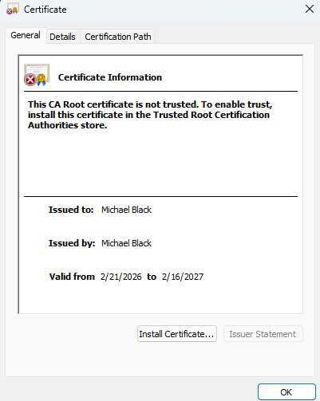

Deploy Cipher
Insert a screenshot below of the checksum verification.
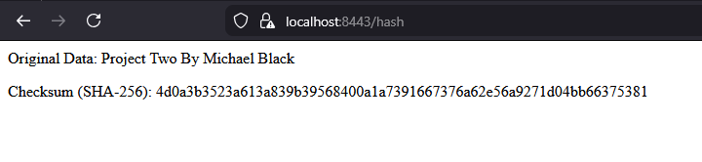

Secure Communications
Refactored application properties file:
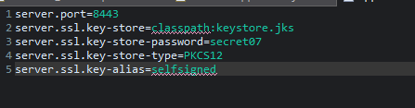

Secondary Testing
SslServerApplication.java page with rest functionality added:
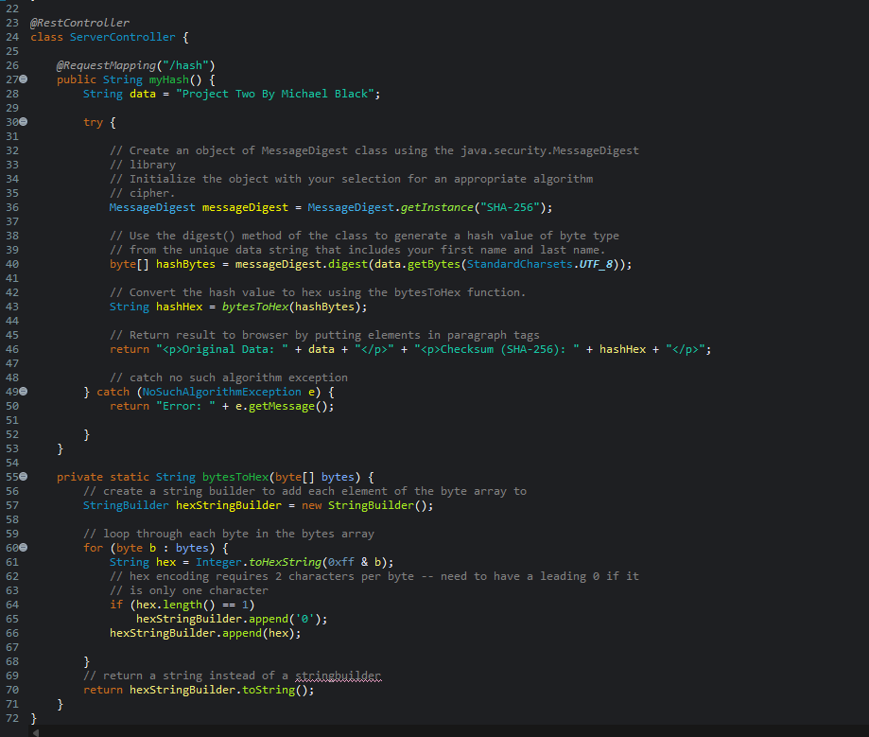
Before functionality added: 13 vulnerable dependencies and 148 vulnerabilities found.
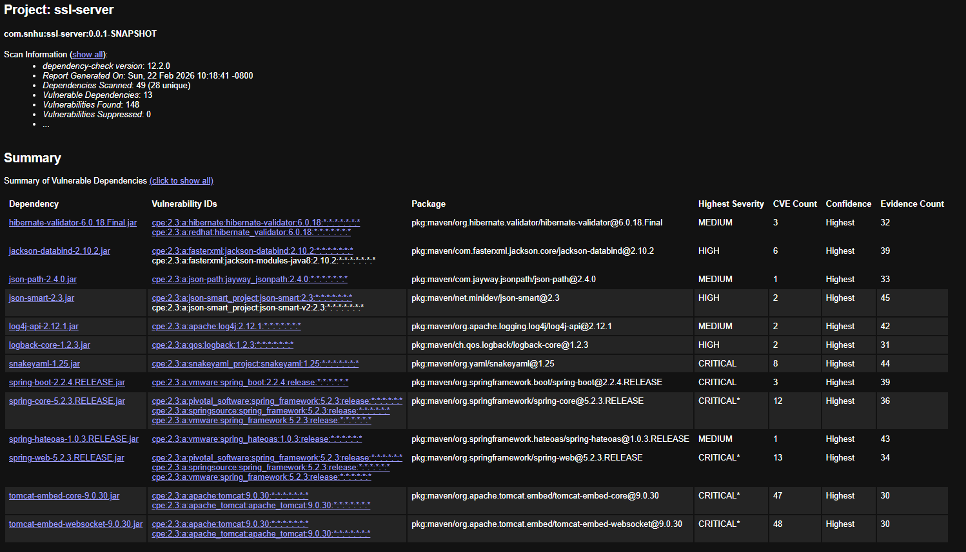

After functionality: Still 13 vulnerable dependencies and 148 vulnerabilities found
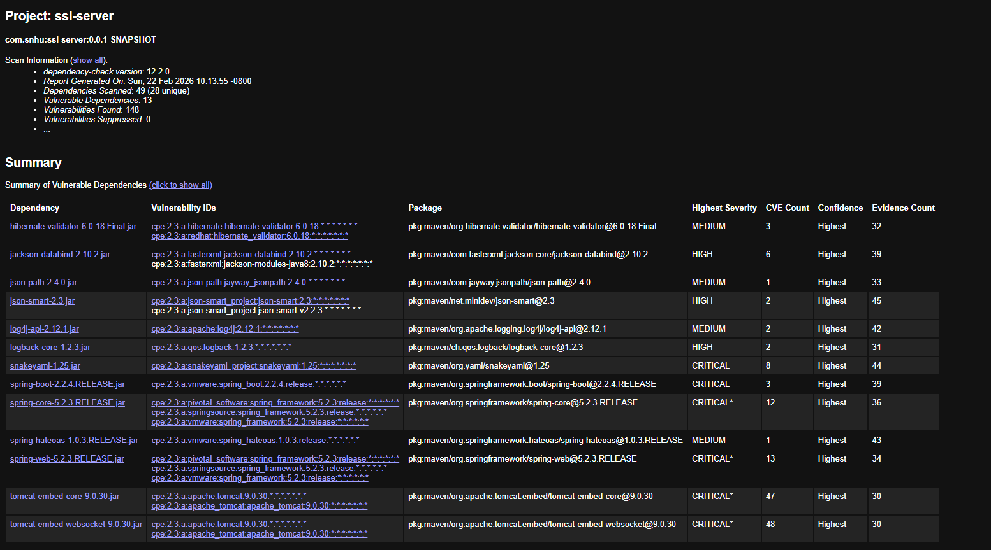
*Please see functional testing section below regarding the neutralization of these vulnerabilities (which existed before and after changes to the main java file).
Screenshot of problems tab to prove no compilation errors (no red errors, only warnings):
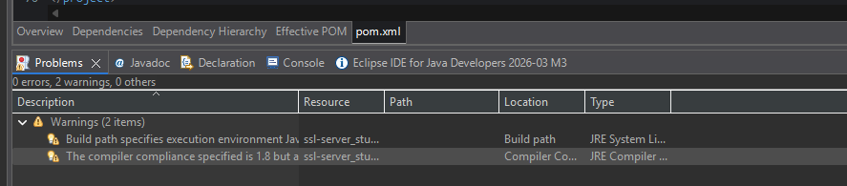

Functional Testing
As shown above, the program is functionally sound, compiles, produces the secure webpage. That said, based on the vulnerabilities found above, it was prudent to update the libraries in the pom. The following properties were added:
<snakeyaml.version>2.5</snakeyaml.version>
<log4j2.version>2.25.3</log4j2.version>
<json-path.version>2.10.0</json-path.version>
<json-smart.version>2.6.0</json-smart.version>

Additionally, the spring-boot-starter-parent was updated to version 4.0.3 and the java.version was updated to 17.
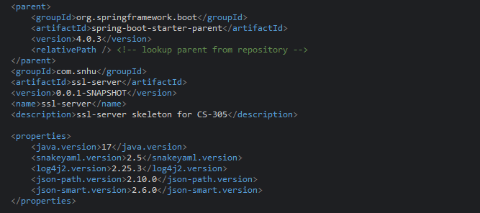
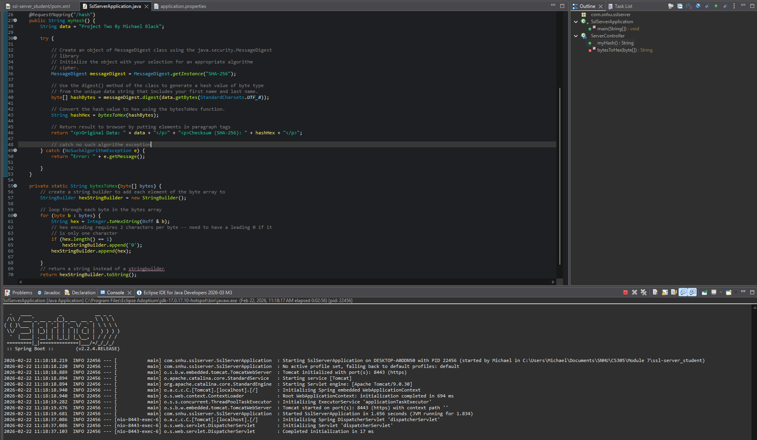

Summary

There were no syntactical or logical vulnerabilities – but there were security vulnerabilities. As reported above, to comply with security testing protocols, the latest library versions were used. To ensure that the previous vulnerabilities were addressed, the dependency check was ran a third time. As shown in the screenshot below, all vulnerabilities were neutralized (0 vulnerable dependencies, 0 vulnerabilities found):
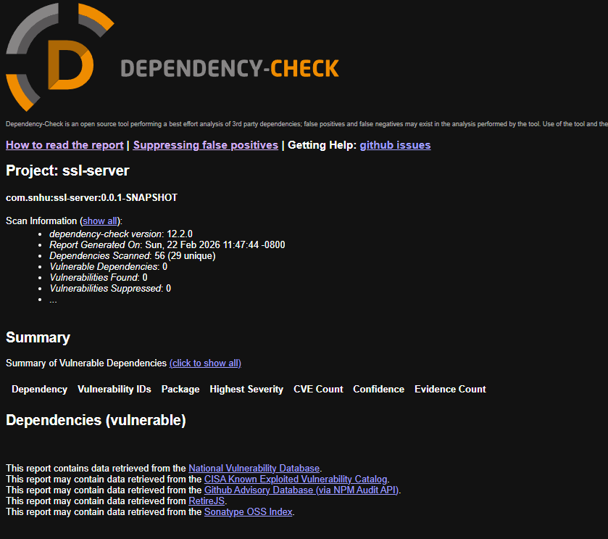

Industry Standard Best Practices

Best practices for maintaining the software application’s existing security mainly involves 1)using the dependency check to identify vulnerabilities; 2)updating libraries to address those vulnerabilities; and 3)rerunning the dependency check to ensure those vulnerabilities were addressed as expected; 4)Using HTTPS; 5)Using a an industry standard algorithm cipher; 6)using an industry-standard cryptographic hash function.
With these best practices in mind, the following actions were taken: 1)Vulnerabilities were identified using the dependency check report; 2)Libraries updated; 3)Dependency check report ran again to confirm resolution; 4)Using port 8443 in application properties for https; 5)Using AES-256 when creating the jks/pkcs12 file that is referenced in application.properties; 6)Using SHA-256 hash function to hash the message which was shown in the checksum verification.

The value of applying industry standard best practices listed above for secure coding is ensuring that we have done our due diligence in protecting customer data and application integrity. New threats can occur everyday and it can’t be assumed that every attack can be blocked. However, by using the latest libraries and best industry practices, we can prove to an audience that reasonable measures were taken. By following these practices, we are preventing release of confidential data, reducing financial losses, protecting reputation, and preventing legal charges.

References:
1)National Institute of Standards and Technology. (2001). Announcing the Advanced Encryption Standard (AES) (FIPS Publication No. 197). U.S. Department of Commerce.
https://doi.org/10.6028/NIST.FIPS.197
2)National Institute of Standards and Technology. (2023). Advanced Encryption Standard (AES) – FIPS 197 (Updated 2023). U.S. Department of Commerce.
https://csrc.nist.gov/publications/detail/fips/197/final
3) National Institute of Standards and Technology. (n.d.). Hashing. NIST Computer Security Resource Center Glossary. https://csrc.nist.gov/glossary/term/hashing

4) National Institute of Standards and Technology. (2015). Secure hash standard (SHS) (FIPS Publication 180-4). U.S. Department of Commerce. https://doi.org/10.6028/NIST.FIPS.180-4

5) National Institute of Standards and Technology. (n.d.). Security strength. NIST Computer Security Resource Center Glossary. https://csrc.nist.gov/glossary/term/security-strength

6) National Institute of Standards and Technology. (2004). Development history of random number generation. U.S. Department of Commerce. https://csrc.nist.gov/csrc/media/events/random-number-generation-workshop-2004/documents/developmenthistory.pdf

7) Barker, E., & Kelsey, J. (2015). Recommendation for random number generation using deterministic random bit generators (NIST Special Publication 800‑90A Revision 1). National Institute of Standards and Technology. https://doi.org/10.6028/NIST.SP.800-90Ar1

8) Barker, E., & Kelsey, J. (2015). Recommendation for random number generation using deterministic random bit generators (NIST Special Publication 800‑90A Revision 1). National Institute of Standards and Technology. https://doi.org/10.6028/NIST.SP.800-90Ar1

9) Menezes, A. J., van Oorschot, P. C., & Vanstone, S. A. (1996). Handbook of applied cryptography. CRC Press

10) Barker, E. (2019). Transitioning the use of cryptographic algorithms and key lengths (NIST Special Publication 800-131A Revision 2). National Institute of Standards and Technology. https://doi.org/10.6028/NIST.SP.800-131Ar2

11) National Institute of Standards and Technology. (2001). Announcing the Advanced Encryption Standard (AES) (FIPS Publication 197). U.S. Department of Commerce https://doi.org/10.6028/NIST.FIPS.197

12) National Institute of Standards and Technology. (2022). Status report on the third round of the NIST post‑quantum cryptography standardization process (NISTIR 8413). U.S. https://doi.org/10.6028/NIST.IR.8413

13) Ferguson, N., Lucks, S., Schneier, B., Whiting, D., Bellare, M., Kohno, T., Callas, J., & Walker, J. (2010). The Skein hash function family. In Submission to NIST (Round 3).

